Toronto, ON, Canada: Sustainable Street Development for Multimodal use

Theodore Kim

URB 3874: Sustainable Transportation in Cities

March 9, 2018

**Introduction**

Well planned streets are a critical component in the development of a sustainable urban transportation system. While subterranean and elevated transit options like heavy and light rails are often preferred amongst urban riders, the reality is that the most prolific transportation methods, private automobile and public bus[1], rely on streets as their transportation media. Therefore, having well designed streets are vital for the safe and quick operation of these modes. In addition to road-based transportation systems, street design has an impact on promoting pedestrian and bicycle transportation modes. Through various design decisions, streets could make “human” transportation a more safe and convenient option for individuals, which in turn can promote higher density forms of transportation like heavy and light rail. Hence smart street decision is vital for the development of an overall sustainable urban transportation network.

What defines a “street?” According to Merriam-Webster dictionary, a street is “a thoroughfare especially in a city, town, or village that is wider than an alley or lane and that usually includes sidewalks.”[2] Hence, the term “street” will be used to refer to the entirety of the area between buildings in a city; components of a street includes the “sidewalk,” or the pedestrian component, and the “road” or the vehicle transportation component. Similarly, vital to this paper is the concept of “street design.” Street design refers to the design decisions and principles which contribute to the street’s physical structure. Hence, it encompasses features like bike lanes or dedicated bus travel lanes. Especially important to urban planners is the use of the “in-between space” or the boundary between the sidewalk and road. It is the use of this area where streets see the most innovative use with introduction of features like dedicated bicycle lanes and parking lanes.

A close up of a street

Description generated with high confidence

Figure 1. The components of a street including the roadway and sidewalk zones, and the “in-between” zone for development.

Julian Mirabelli, “Reimagining Toronto’s Road with Complete Streets Guidelines.” Urban Toronto, last modified: March 5, 2016, http://urbantoronto.ca/news/2016/03/reimagining-torontos-roads-complete-streets-guidelines

Toronto, the subject of this paper’s case study, is a metropolis in the south eastern Canadian province of Ontario. Located on the northwestern corner of Lake Ontario, Toronto is the largest urban population center in Canada, with a population of 6.3 million people according to a 2017 Canadian population estimate.[3] The city is similarly the most population dense area in Canada, with a geographic area of 5,905 square kilometers (2,280 square miles) and an average population density of 945.4 persons per square kilometer.[4] This is significantly higher than the national average of 3.7 persons per square kilometer.[5] Being a relatively dense urban environment, Toronto has developed an extensive public transportation system including four subway lines, 11 streetcar routes and over 140 bus routes.[6] Yet, the city still has a car ownership of 85%, with 82% of resident choosing to commute via automobile daily, 12% via public transit, and 6% via bicycle or foot.[7]

Toronto’s diverse multimodal transportation offerings prove a challenge to the development of sustainable street design. While other urban environments may only require accommodations for automobile and bus traffic on its roads, Toronto’s streets must also take into account its streetcars, which require dedicated tracked embedded into roadways and stations, yet share the road with other modes of transportation. Similarly, being an old city, Toronto faces challenges presented by its historical development, like its patched gridiron street pattern, which pose challenges to its streets’ accessibility and safety. The city has attempted to address these issues through various urban planning initiatives including its Complete Streets plan, essentially using individualized street categorization in order to identify possible improvements to all of its streets in a way that would most directly benefit its users.

The effects of innovative street design on the safety and effectiveness of various pedestrian, bicycle, and road-dependent transportation modes will be discussed in the context of the city of Toronto, Ontario, Canada in this paper. This includes the city’s challenges to sustainable street design as a result of its historical development, and how the city has addressed these issues and innovated on its street design strategy. The lessons Toronto learned in street design will then be applied to the development of complete streets in New York City.

**History of Transportation and Urbanization in Toronto**

Toronto was founded in 1793 as the town of York by Lieutenant Governor John Graves Simcoe. The location of the city was chosen to be the northwest corner of Lake Ontario for its naturally shielded harbor, which Simcoe believed would enable the settlement to control Lake Ontario and the Niagara peninsula.[8] The original city was planned on two separate gridiron town-plots, a 10-block area a part of the present-day “Distillery District” and a larger 12-block parcel to its west, currently referred to as “Old Toronto”. Connecting these two streets was the modern thoroughfares of Dundas and Yonge Streets.[9]

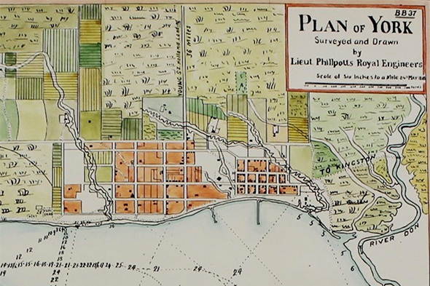

Figure 2. An historical map showing the original town plots in orange, a smaller plot to the east a larger plot to the west

Derek Flack, “Where the Toronto street grid got its start.” blogTo, last modified: November, 5, 2016, https://www.blogto.com/city/2016/11/where_the_toronto_street_grid_got_its_start/

From early in its history, street design was not a major priority to the city. In 1834, the city incorporated as Toronto to rid it of the negative connotations associated with the previous name, York. This included the nickname “Muddy York” that was derived from the city’s grossly unmaintained and unpaved streets, which were often the consistency of quicksand due to rain and runoff from streams and rivers north of the city.[10] What few roads had sidewalks, were made of flammable wooden planks.[11] The city had little resources to fix or develop the roads throughout the majority of the 19th century.[12] In fact, when the Toronto Street Railway Company (TRC) began laying down track for its horse-drawn streetcars in the 1860s, many privately owned wagons utilized the tracks to traverse the still unpaved roads.[13] During the 1890s there was an official movement by city engineers to fully pave all of the city’s streets with asphalt, the modern pavement used by roads today, which included on most streets a concrete sidewalk for non-vehicular traffic.[14] By the turn of the century, the streets were being shared by horses, early automobiles, electric streetcars and pedestrians.

The final change in the development of the contemporary streets of Toronto was the construction of the subway in the 1950s. Built in the post-war era to accommodate the growing commuter traffic along the Toronto’s busiest street, the Yonge Street subway line was constructed using a trenching method in which the subway tunnels were constructed by digging out trenched and eventually covering them with concrete and asphalt.[15] Another step taken during this time was to bury the majority of the power lines in downtown Toronto and electrify the streetcar rails in order to eliminate the need for overhead electrical lines.[16] By doing so, the need for extra space along streets to accommodate electrical poles was eliminated freeing up sidewalk area for pedestrians.

Many of the challenges the city’s streets face is due to the historical development of its transportation systems, namely the city’s street patterns as a result of its original foundation and its heavy multimodal traffic, especially in its downtown area. Both factors prove challenges to the safety of both pedestrians and cyclists, as well as increase congestions for both private and public transportation modes.

While accessible to pedestrians, the city’s gridiron network contributes to a greater crash rate amongst automobiles due to its increased permeability; the more cars share the same road, the greater the risk for collision.[17] Also due to its standardized gridiron development, Toronto lacks the “major and minor street” system that is common in urban areas like New York, where high traffic avenues are connected by low traffic streets.[18] As a result, it is common to have several bidirectional, multilane streets width widths greater than 10 feet (3.1m) intersecting with one and other,[19] which results in an increased crash rate as cars make turns less cautiously, and are more likely to get into an accident.[20] Gridiron street patterns also prove less safe for cyclists who are more likely to have to cross traffic with an increased number of intersections characteristic of gridiron networks, thus increasing their chance of collision with a turning automobile.[21] Therefore street design decisions must take into account the safety concerns posed by the gridiron pattern.

Toronto’s multimodal road use is also both a blessing and a curse to its street network and must be addressed in any sustainable street design standards that the city implements. In Toronto, the majority of street car lines operate on nondedicated track, in other words, track that shares right-of-way with private automobiles and cars on the road. This poses a unique threat of cross modal collisions and congestion. In 2014, the Toronto Transit Commission reported, nearly 18,000 crashes between its streetcar, bus and Wheel-Trans (Toronto’s Paratransit system) systems over a five-year period, the majority of which were deemed to have been “unavoidable.”[22] Congestion is also the result of shared modal traffic on streets, with the primary source being that the majority of streetcars do not have dedicated lanes or sidewalk boarding, requiring passengers to cross the street to enter the streetcar, holding up traffic in the process.[23] The average TTC streetcar and buse experiences ten to twenty minutes of delays daily due to traffic congestion, with an estimate $1.7 million (CAD) in lost revenue.[24] These issues could be solved with smarter street signaling, dedicated travel lanes (which some streets in Toronto already have completed) and better passenger boarding options for the various modes.

**Toronto’s Innovation in Street Design**

Though historically ineffective in solving street infrastructure issues, Toronto has been recently making steps towards improving its thoroughfares with sustainable street design standards through various planning initiatives. The goals of said plans are to make streets friendlier to public transit, cyclists and pedestrians, and to deprioritize low density automobile traffic. The city’s Complete Streets guidelines will be discussed as the driving document for sustainable street design.

“Complete streets” is not a concept unique to Toronto, but is a design initiative which aims to design streets “for all users and use cases,”[25] in other words, to accommodate modes of transportation outside of automobile and vehicular traffic. The complete street design standard was created with National Complete Streets Coalition, an urban design advocacy group, in 2005.[26] While it does not include a concrete code of standards, the general concepts behind the project include the reduction of traffic lane width to reduce urban traffic speed, the created of protected, dedicated bike lanes, addition of “green space” to sidewalks, and traffic islands to reduce pedestrian crosswalk length and reduce turning speeds between major thoroughfares.[27]

In March 2016, the Toronto Design Review Panel introduced the city’s version of Complete Streets as a standard for future street development and renovation.[28] The standard prioritizes pedestrians and cyclists, then public transit, and places private automobiles at the lowest priority for street usage as it has identified those modes as being the most sustainable options for urban transportation.[29] Hence, the plan promotes a new design paradigm of “outside in development”—focusing on *multimodal* safety and accessibility—rather than the traditional automobile-centric “inside out approach.” Such a paradigm called for reduced roadway zone size, and increased utilization of the “in-between zone” for cross modal accommodation and safety.[30]

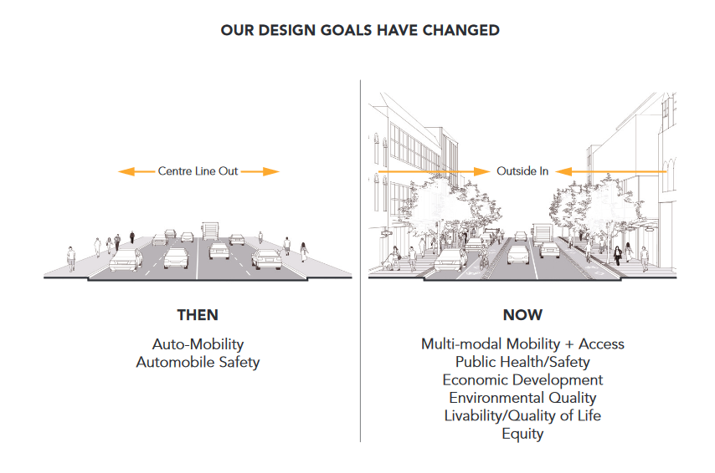

Figure 3. A comparison the “inside out” paradigm (left) versus the Complete Street’s “outside in” paradigm

“Complete Streets Guidelines”: 11

Another feature of the city’s version of the initiative is to identify types of streets and make guidelines specific to each street’s usage pattern and population rather than assuming a “one size fits all” approach.[31] In doing so, the city will be better able to allocate resources to streets whose design much be changes radically, like the city’s commercial districts, compared to streets whose current layout is sufficient for sustainable development, such as residential streets. The plan identifies several road types, and the main categories are outlined in Figure 4.

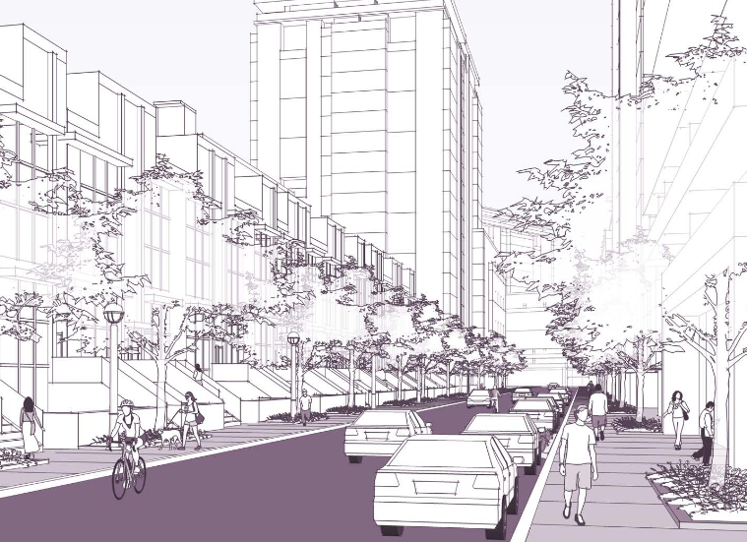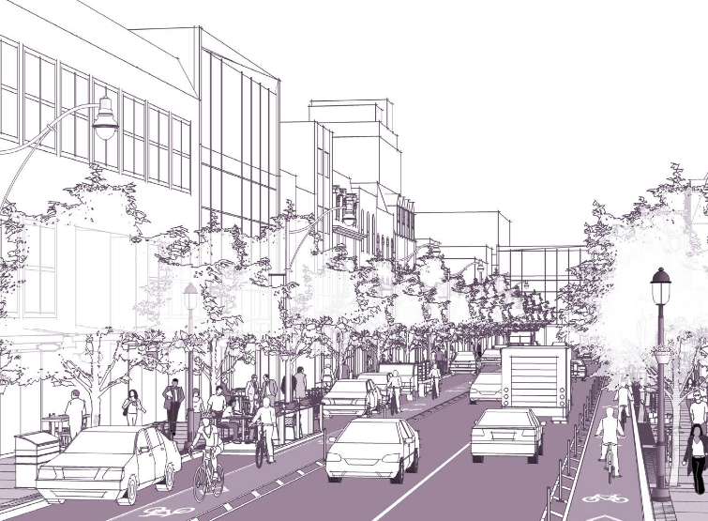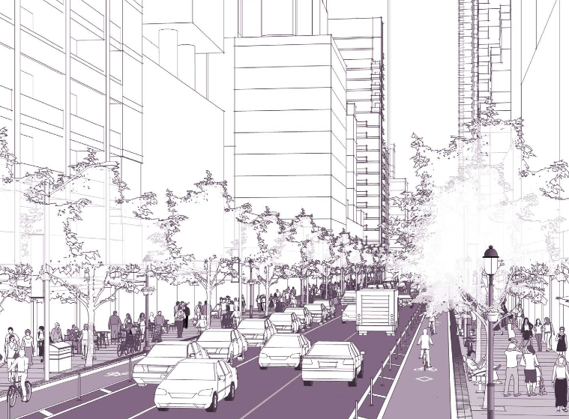

**Low-Density Residential**

**Downtown Commercial**

**Avenue / Neighborhood Main St.**

Figure 4. Three of the street categories identified by Toronto’s Complete Streets plan. From left to right: **Downtown Commercial:** high cross modal traffic and community exposure, bidirectional streets to promote traffic flow, dedicated parking lanes outside of cycling lanes to slow traffic and protect cyclists / pedestrians, **Low-Density Residential**: low automobile traffic, little cross modal traffic, emphasis on parking and reduction of permeability with a single unidirectional lane, **Avenue / Neighborhood Main St.**: reduce traffic by narrowing cross modal lanes, extended sidewalks to improve pedestrian crossings and expose sidewalks to public transit boarding, unexposed parking lane to reduce parking turnover.

“Complete Streets Guidelines”: 11

Finally, the plan identifies changes that could be made to the city’s streets in order to improve riders’ experience on public transit and improve on safety and congestion issues discussed in the previous section. The development of sidewalk “bulb-outs” or portions of the sidewalk that extend into the parking or bike line to allow seamless transfer of pedestrians from the sidewalk to buses or streetcars, would improve rider’s safety and traffic flow.[32] It also proposes the allotment of reserved transit lanes for buses, streetcars and similar “high occupancy vehicles,” to prevent delays and facilitate the movement of as many individuals as possible. The plan makes allowances for shared lanes on streets where a dedicated lane cannot be spared for a single mode. In such cases improves signaling can be used to synchronize traffic with passenger boarding of buses and streetcars.[33]

Toronto’s Complete Streets guidelines have not yet begun widespread implementation as it lacks a definitive implementation strategy. However, the city has already completed several large street design projects using uncodified versions of Complete Street standards and continues to move forward on various other projects such as the Adelaide Street bike lane addition which conform to the recently introduced Complete Street standards. One of the largest projects to adopt a Complete Street standard in Toronto to existing roadway in Toronto is downtown Yonge Street. Although the project began before the formal introduction of the Complete Streets guidelines, the Yonge Street rework is an example of the effectiveness of its design principles.[34] Yonge Street serves as Toronto’s primary thoroughfare and previously featured four bidirectional travel lanes, which were since reduced to two travel lanes. The created space was utilized for pedestrian plazas, dedicated bicycle lanes, and increased green space. A pedestrian plaza was created at Yonge’s intersection with yet another busy street, Dundas, as Toronto’s version of New York City’s Times Square renovation.[35] A later economic impact study estimated 10 – 20% increase in retail activity since the street’s redesign, a 30% increase in pedestrian traffic in the area, and a 70% reduction of automobile related injuries on the revised stretch of street.[36] The success and the experience of the Yonge Street redesign prompted the development of a codified Complete Streets guidelines and is demonstrative of the effectiveness of well designed streets to encourage cross modal transportation and economic development.

Bibliography

“A Brief History of Transit in Toronto.” Transit Toronto, last modified: June 25, 2015, https://transit.toronto.on.ca/spare/0012.shtml

“A Provincial Centre, 1793 – 1851.” The History of Toronto, last modified: June 9, 2015, https://www.toronto.ca/explore-enjoy/history-art-culture/museums/virtual-exhibits/history-of-toronto/a-provincial-centre-1793-1851/

Brian B. Bettencourt, “Toronto to narrow traffic lanes in hopes of increasing safety.” *The Globe and Mail*, last modified: November 24, 2014, https://www.theglobeandmail.com/news/toronto/toronto-to-narrow-traffic-lanes-in-hopes-of-increasing-safety/article21743109/

“Canada’s First Subway.” Toronto City Government, accessed: March 7, 2018, https://www.toronto.ca/city-government/accountability-operations-customer-service/access-city-information-or-records/city-of-toronto-archives/whats-online/web-exhibits/canadas-first-subway/

“Complete Street Guidelines.”City of Toronto, last modified: November 5 2017, https://www.toronto.ca/services-payments/streets-parking-transportation/enhancing-our-streets-and-public-realm/complete-streets/complete-streets-guidelines/: 1 – 3

“Congestion? It’s the streetcars, stupid.” The Toronto Sun, last modified: May 17, 2017, http://torontosun.com/2017/05/16/congestion-its-the-streetcars-stupid/wcm/ba646b51-6c19-41b0-906f-3bef6966d063

David Wencer, “The Roads to Muddy York.” Heritage Toronto, last modified: January 7, 2013, http://heritagetoronto.org/the-roads-to-muddy-york/

Derek Flack, “Where the Toronto street grid got its start.” blogTo, last modified: November, 5, 2016, https://www.blogto.com/city/2016/11/where_the_toronto_street_grid_got_its_start/

“Downtown Yonge Street, Toronto, Ontario.” Complete Streets for Canada, last modified: February 2015, http://completestreetsforcanada.ca/examples/downtown-yonge-street-toronto-ontario

Edwin C. Guillet, *Toronto: From Trading Post to Great City*. (Toronto: The Ontario Publishing Co.: 1934), 56

Eric Andrew-Gee, “TTC reports nearly 18,000 crashes since 2009.” The Toronto Star, last modified: July 4, 2014, https://www.thestar.com/news/gta/2014/07/04/ttc_reports_nearly_18000_crashes_since_2009.html

“General Information.” Toronto Transit Commission, accessed: March 8, 2018, http://www.ttc.ca/Routes/General_Information/General_Information.jsp

Matthew J. Roorda, *Toronto Area Car Ownership Study: A Longitudinal Survey and a Preliminary Analysis of Results*, Master's thesis, University of Toronto, 1998 (Ottawa: National Library of Canada, ON), 66.

Phillip Gordon Mackintosh, “Asphalt Modernism on the Streets of Toronto, 1890–1900,” *Material Culture Review* 62, Fall: 7

Julian Mirabelli, “Reimagining Toronto’s Road with Complete Streets Guidelines.” Urban Toronto, last modified: March 5, 2016, http://urbantoronto.ca/news/2016/03/reimagining-torontos-roads-complete-streets-guidelines

“National Complete Streets Coalition.” Smart Growth America, date accessed: March 9, 2018, https://smartgrowthamerica.org/program/national-complete-streets-coalition/

Safer Streets, Stronger Economies.” Smart Growth America, last modified: March 2015, https://smartgrowthamerica.org/app/uploads/2016/08/safer-streets-stronger-economies.pdf

“Street,” Merriam-Webster.com, accessed: March 7, 2018. https://www.merriam-webster.com/dictionary/street.

“Table 4-4: Urban Transit Ridership by State and Transit Mode: 2013.” Bureau of Transportation Statistics, last modified: July, 2015, https://www.rita.dot.gov/bts/sites/rita.dot.gov.bts/files/publications/state_transportation _statistics/state_transportation_statistics_2015/chapter-4/table4_4.

Wesley Earl Marshall and Norman W. Garrick, “Does street network design affect traffic safety?,” *Accident Analysis and Prevention* 43 (2011): 769 - 781

1. “Table 4-4: Urban Transit Ridership by State and Transit Mode: 2013.” Bureau of Transportation Statistics, last modified: July, 2015, https://www.rita.dot.gov/bts/sites/rita.dot.gov.bts/files/publications/state_transportation _statistics/state_transportation_statistics_2015/chapter-4/table4_4.
2. “Street,” Merriam-Webster.com, accessed: March 7, 2018. https://www.merriam-webster.com/dictionary/street.
3. “Focus on Geography Series: Census metropolitan area of Toronto, Ontario.” Statistics Canada, last modified: February 21, 2016, http://www12.statcan.gc.ca/census-recensement/2011/as-sa/fogs-spg/Facts-cma-eng.cfm?LANG=Eng&GK=CMA&GC=535
4. Ibid.
5. Ibid.
6. “General Information.” Toronto Transit Commission, accessed: March 8, 2018, http://www.ttc.ca/Routes/General_Information/General_Information.jsp
7. Matthew J. Roorda, *Toronto Area Car Ownership Study: A Longitudinal Survey and a Preliminary Analysis of Results*, Master's thesis, University of Toronto, 1998 (Ottawa: National Library of Canada, ON), 66.
8. “A Provincial Centre, 1793 – 1851.” The History of Toronto, last modified: June 9, 2015, https://www.toronto.ca/explore-enjoy/history-art-culture/museums/virtual-exhibits/history-of-toronto/a-provincial-centre-1793-1851/
9. Derek Flack, “Where the Toronto street grid got its start.” blogTo, last modified: November, 5, 2016, https://www.blogto.com/city/2016/11/where_the_toronto_street_grid_got_its_start/
10. David Wencer, “The Roads to Muddy York.” Heritage Toronto, last modified: January 7, 2013, http://heritagetoronto.org/the-roads-to-muddy-york/
11. Ibid.
12. Edwin C. Guillet, *Toronto: From Trading Post to Great City*. (Toronto: The Ontario Publishing Co.: 1934), 56
13. “A Brief History of Transit in Toronto.” Transit Toronto, last modified: June 25, 2015, https://transit.toronto.on.ca/spare/0012.shtml
14. Phillip Gordon Mackintosh, “Asphalt Modernism on the Streets of Toronto, 1890–1900,” *Material Culture Review* 62, Fall: 7
15. “Canada’s First Subway.” Toronto City Government, accessed: March 7, 2018, https://www.toronto.ca/city-government/accountability-operations-customer-service/access-city-information-or-records/city-of-toronto-archives/whats-online/web-exhibits/canadas-first-subway/
16. Ibid.
17. Wesley Earl Marshall and Norman W. Garrick, “Does street network design affect traffic safety?,” *Accident Analysis and Prevention* 43 (2011): 769 - 781
18. Brian B. Bettencourt, “Toronto to narrow traffic lanes in hopes of increasing safety.” *The Globe and Mail*, last modified: November 24, 2014, https://www.theglobeandmail.com/news/toronto/toronto-to-narrow-traffic-lanes-in-hopes-of-increasing-safety/article21743109/
19. Ibid
20. Wesley Marshall and Norman Garrick, 769 - 781
21. Ibid, 789 - 790
22. Eric Andrew-Gee, “TTC reports nearly 18,000 crashes since 2009.” The Toronto Star, last modified: July 4, 2014, https://www.thestar.com/news/gta/2014/07/04/ttc_reports_nearly_18000_crashes_since_2009.html
23. “Congestion? It’s the streetcars, stupid.” The Toronto Sun, last modified: May 17, 2017, http://torontosun.com/2017/05/16/congestion-its-the-streetcars-stupid/wcm/ba646b51-6c19-41b0-906f-3bef6966d063
24. Ibid.
25. “National Complete Streets Coalition.” Smart Growth America, date accessed: March 9, 2018, https://smartgrowthamerica.org/program/national-complete-streets-coalition/
26. Ibid.
27. “Safer Streets, Stronger Economies.” Smart Growth America, last modified: March 2015, https://smartgrowthamerica.org/app/uploads/2016/08/safer-streets-stronger-economies.pdf
28. Julian Mirabelli, “Reimagining Toronto’s Road with Complete Streets Guidelines.” Urban Toronto, last modified: March 5, 2016, http://urbantoronto.ca/news/2016/03/reimagining-torontos-roads-complete-streets-guidelines
29. “Complete Street Guidelines.”City of Toronto, last modified: November 5 2017, https://www.toronto.ca/services-payments/streets-parking-transportation/enhancing-our-streets-and-public-realm/complete-streets/complete-streets-guidelines/: 1 - 3
30. Ibid.
31. Ibid, 15 - 20
32. Ibid, 105 - 106
33. Ibid, 104
34. “Downtown Yonge Street, Toronto, Ontario.” Complete Streets for Canada, last modified: February 2015, http://completestreetsforcanada.ca/examples/downtown-yonge-street-toronto-ontario
35. Ibid.
36. Ibid.